2017-05-30 Lab Meeting – Tiffany Lowe-Power

Cloning case studies: Rs potADBC mutant
Overall Goal: Identify the putrescine exporter in Rs strain GMI1000

Step 1: Background research on PotADBC
Best studied in E. coli. E. coli has many polyamine transporters, including:
potADBC: ATP-Binding Cassette (ABC)-type importer with preference for Spd
potFGHI: ABC-type importer with preference for Putrescine.
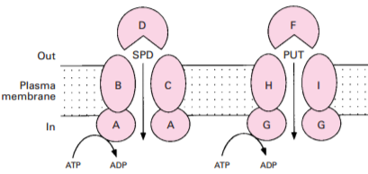Igarashi and Kashiwagi 1999 Biochem J.
ABC transporters are usually importers or exporters.
Core components:
- cytoplasmic ATPase (e.g. PotA), which provides energy to transport against a concentration gradient.
- Permeases (e.g. PotB and PotC), which form the transmembrane channel.
- Periplasmic substrate binding proteins (e.g. PotD), which bring the substrate to the channel. Only present in importers, not exporters.
Note: ABC transporters have minor bidirectional transport according to Phil. Poole’s group (Hosie et al. 2001, Mol Micro). However, they have greater affinity for the substrate at the import face than the export end of the channel, and generally only transport in one direction.

Is putrescine exporter via PotADBC in Rs?
Because Rs does not produce or accumulate spermidine, I hypothesize this PotADBC locus (Rsc1731-34) is a PotFGHI-type putrescine import system. I don’t think PotADBC is the putrescine exporter, but Rs lacks homologs of known polyamine export systems.
Note: The crystal structures of E. coli PotD and PotF protein bound to spermidine/putrescine are solved and the Igarashi 1999 review highlights which residues contribute most to substrate specificity. Future task: Align Rs PotD with these proteins and determine if these residues are conserved. Additionally, Rs PotD can be modeled onto the E. coli PotD/F structures to look at the substrate binding pocket residues.

Rs potADBC genes
The potADBC genes are in a single locus:
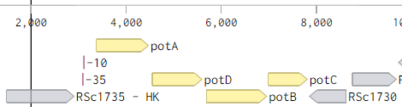
Protip: You can export chunks of the Rs genome sequence from NCBI into a .FLAT file, which you can import into Benchling. I then tidy up annotations and change colors to highlight the important information. I recommend displaying the DNA strand that is SENSE to your gene of interest (ie, generate a reverse complement if you need to) so you don’t mix up upstream & downstream genes.
Operon? The potADBC gene organization is consistent with operon structure, and the RSc1730 ORF cannot be on the same mRNA transcript because it is divergent.
Promoter? There is a 469 bp gap between RSc1735 and potA, which suggests these genes are on different transcripts despite the same direction. However, it’s possible they’re on the same transcript.
>Bprom algorithm to detect E. coli Sigma-70 type promoters (annotated above in pink)
Promoter Pos: 3142 LDF- 1.39
-10 box at pos. 3127 GCCTACACT Score 45
-35 box at pos. 3104 TTGACG Score 60

Decide which genes to delete:
It’s possible to create a ΔpotADBC mutant lacking the entire transporter.
My first attempt to create a vector to replace the potADBC locus with the gentamycin cassette hasn’t been successful (ie, Gibson reaction yielded E. coli clones with incorrect vectors. Vectors had upstream region, but no downstream region by PCR screen. In case the downstream PCR reaction failed, I digest screened a few Upstream⁺ vectors, and the DNA bands were the wrong sizes).
So I’m trying two things:
pUFR80-potADBC (using different primers for the upstream/downstream region)
pUFR80-potC (I thought this permase mutant might be biochemically cleaner than a potD substrate binding protein mutant...)

Choosing Upstream/downstream regions for homologous recombination:
- Worry about polarity... you want to make sure you don’t affect expression/translation of neighboring genes.
  - We should be good for both the potC and potADBC genes
  - No genes are overlapping our GOIs (genes of interest). This isn’t always the case: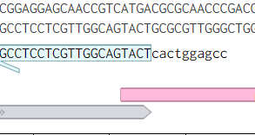

Primerblast to identify primer binding sites:
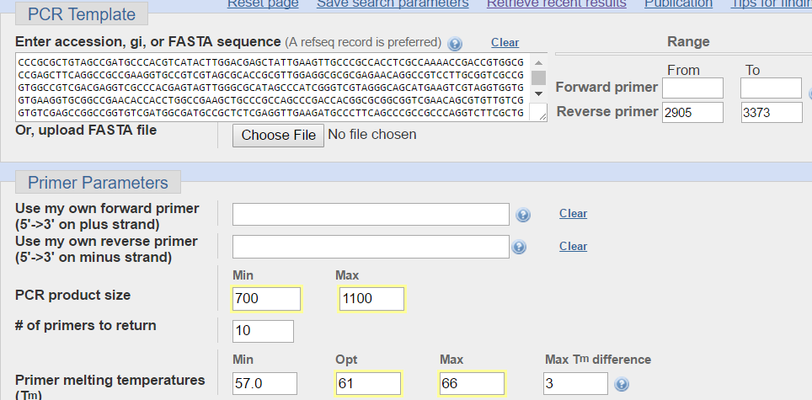
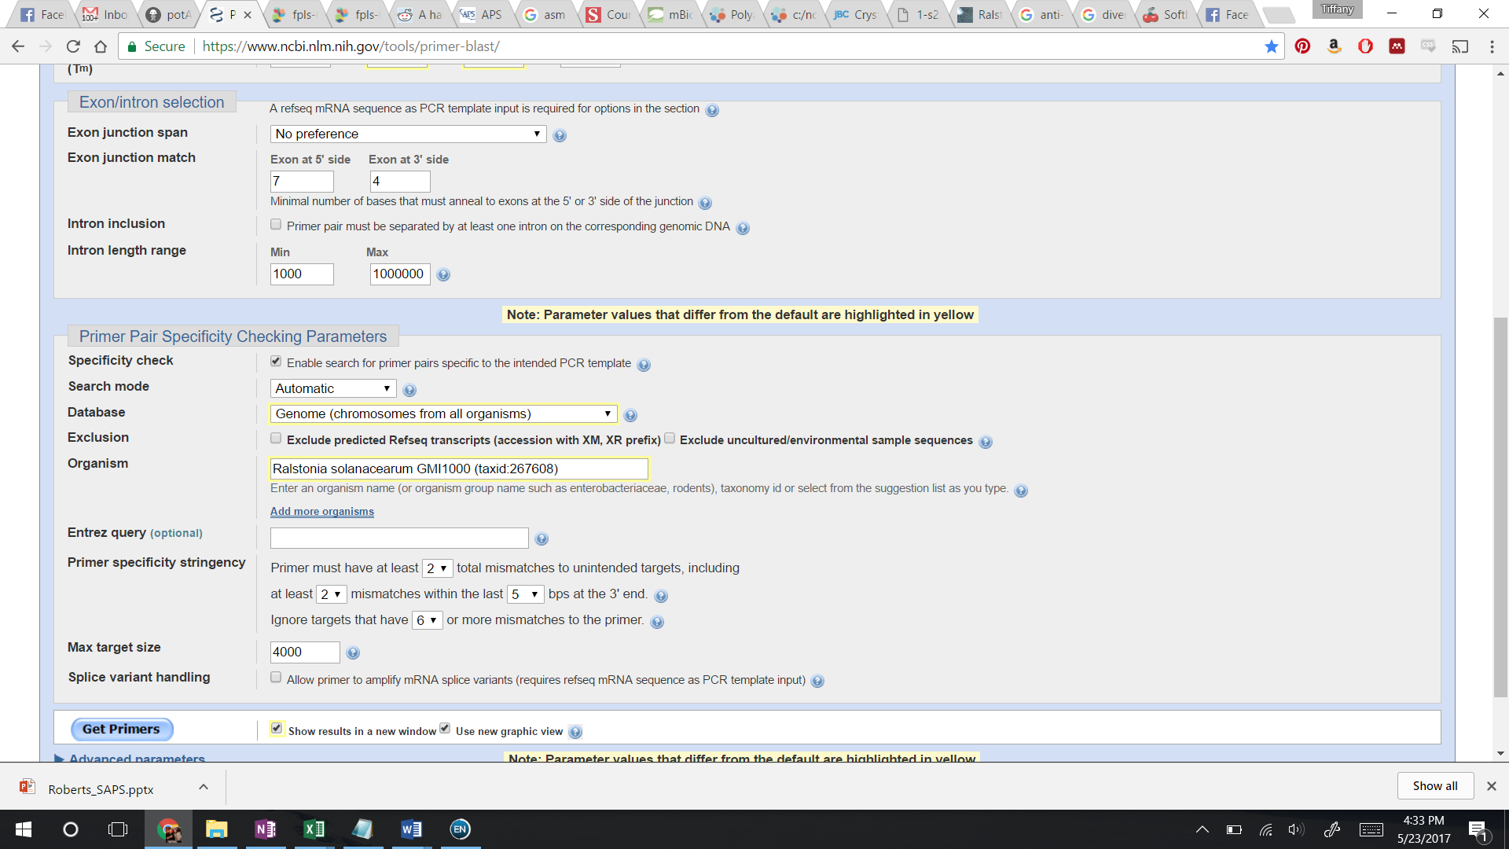
- Copy sequence from Benchling into Primerblast ( www.ncbi.nlm.nih.gov/tools/primer-blast/ )
- For Upstream region, set a range for the Reverse primer that won’t disrupt RSc1735, ie region 2905 to 3373.
If the genes are packed tight like the pink example on page 2, manually choose the reverse primer, ie 18-21 bases with Tm 55-66 C.
- Set PCR product size to 700-1100
- Set Specificity to Database = all Genomes / Organism = GMI1000
- Check the “show results in new window” button.
- While that chugs, I usually will change the Optimal primer Tm from 60C to 61 and 62 (opening new windows on each. (Less down time)
- In Advanced I have used some features. The Excluded regions feature is useful if you’re redesigning primers after PCR/cloning was unsuccessful.
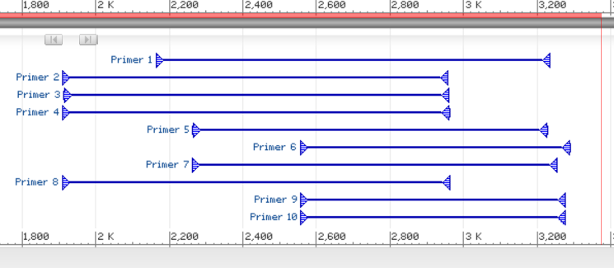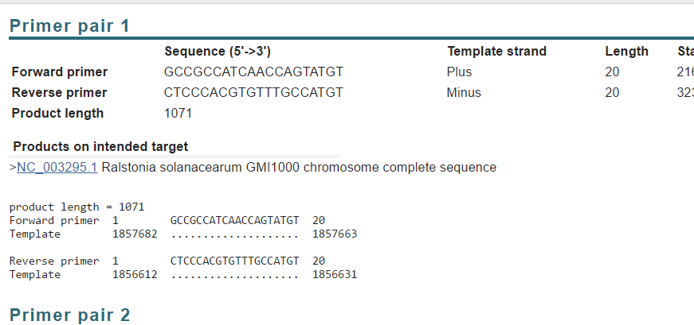
Do the same for the downstream side, Add benchling annotations for the target Upstream/downstream products.
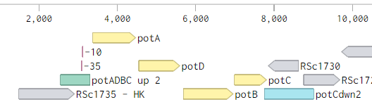
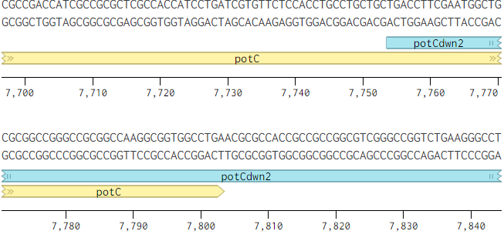
Note: My downstream region will leave 50 bp of the end of potC. However, without a start codon, we shouldn’t have any protein expression. The region after potC is highly GC rich, and I suspect it encodes a transcriptional stop stemloop. Either way, it was a poor region for primers (Primer blast results hit 4-10 regions in the genome)

Design overlaps for Gibson Assembly:
Copy/Paste the Upstream product, Downstream product, and pUFR80 vector sequence into NEBuilder.
Settings: Set pUFR80 as vector backbone, linearize with HindIII digest (No real reason for this other than HindIII is a cheap RE, is present in the lacZ ORF in pUFR80 (enables blue/white screening for inserts), and it’s convenient to always use the same insertion site so you can keep a tube of linearized vector to use for multiple projects.
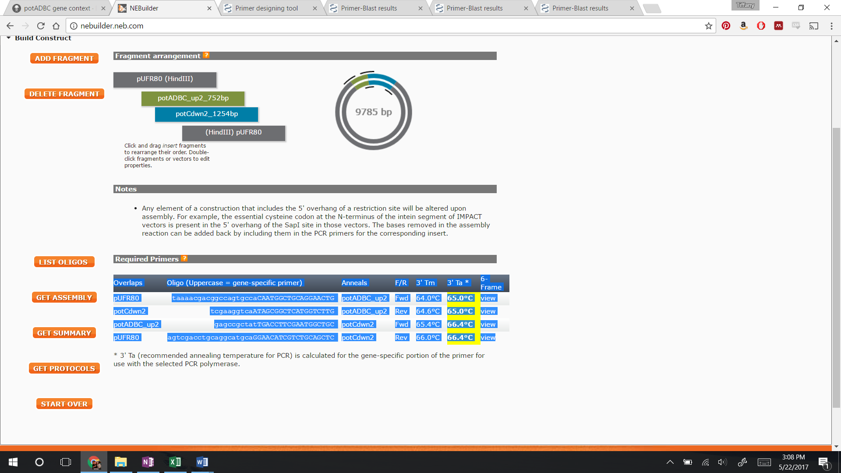
Copy table into your cloning document, add a column to name your primer.
Primer Name | Overlaps | Oligo (Uppercase = gene-specific primer) | Anneals | F/R
TLP13-potADBCup2F | pUFR80 | taaaacgacggccagtgccaCAATGGCTGCAGGAACTGGTG | potADBC_up2 | Fwd
TLP16-potADBCup2R2 | potCdwn2 | tcgaaggtcaATAGCGGCTCATGGTCTTGCC | potADBC_up2 | Rev
TLP17-potCdwn2F3 | potADBC_up2 | gagccgctatTGACCTTCGAATGGCTGCG | potCdwn2 | Fwd
TLP7-potCdwn2R | pUFR80 | agtcgacctgcaggcatgcaGGAACATCGTCTGCAGCTCT | potCdwn2 | Rev
Primer sequence: colors correspond to which DNA fragment they are complementary to. Bold part of primers (my formatting): NEBuilder usually doesn’t make the primers as long as the Primer blast recommended primers. So, I added a few bases back on. (This isn’t something I thought about until recently, but the shorter “specific” region can lead to nonspecific bands.
Copy/paste the vector sequence into a new Benchling file. Add pUFR80 and your gene locus annotations with the “auto annotate” wizard.

Order primers / do PCR
Use a high fidelity polymerase like Kapa HiFi or Q5.

Run 1-2 ul of PCR on gel to check for nonspecific bands
Decide whether to gel extract (Pros: cutting out band=1 DNA fragment. Cons: terrible yield) or directly clean PCR reaction on column.

Digest pUFR80 with HindIII
Clean with Clean & concentrator kit. (Keep extra in the freezer)

Nanodrop DNA fragments

Gibson Assemble
Calculation spreadsheet is in box. (Fancy... allows you to add the appropriate range of picomoles of differently sized DNAs)
Protip: it can be helpful to start reaction without the vector (Gibson Mastermix + Upstream/downstream PCR fragments only). After 5 minutes, add the appropriate volume of vector.

Transform E. coli
Devanshi’s protocol for chemically competent E. coli is on Box. DH5α is a common cloning strain of E. coli.

Plate E. coli for blue/white screening
If you’re inserting into the lacZ of a plasmid, you can use blue/white screening if you add IPTG and XGal to your plates. Blue colonies = empty vector, white = something is inserted.

PCR screening E. coli clones
- M13F/R primers bind to the lacZ region around your inserts. You can screen for band sizes
- Or use your gene specific primers – maybe UpstreamF with Downstream R.
- Colony PCR: Use a toothpick to select a colony. Submerge it in 20 ul water in PCR strip tube. Then use same toothpick to patch to a new LB plate. Boil the colony in the water (10-15 min at >95C). Add 2-3 ul to GoTaq PCR reaction (or other cheap polymerase).

Digest screening E. coli clones
Identify E. coli clones with PCR product of expected size. Start overnights and miniprep (it’s often possible to start the overnight on the same day as the PCR screen). Protip: If you don’t have time to miniprep the next day, you can pellet the cells from the overnight culture & freeze them until miniprep.
Design Restriction Digest Screen in Benchling:
(Thumbnail for restriction digest tools)
Things I look for
- Enzymes that cut the inserts (Protip: Use the “Show enzymes that cut... in the current selection” option)
- Enzymes that cut more than once, but not too many times (2-4 bands depending on plasmid size)
- DNA fragment patterns you can resolve on a gel (ie, avoid enzymes that will yield 2 bands of the near same size)
- Run the virtual digest & benchling will let you know what size bands to look for.

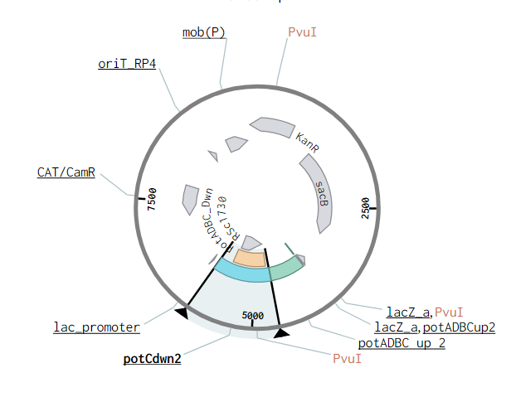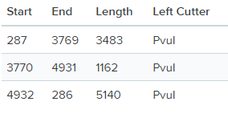

Sequence the inserts
Only if the PCR screen and Digest screen look good. Select 2-3 plasmids to sequence. You can get 0.8-1 kb sequence from the BioTech center. You won’t see the sequence in the first 20-50 bp after the sequencing primer, so M13F/R primers are great to use if you can.

